北 京 科 技 大 学

硕士学位研究生
选题报告及文献总结
论文题目：



指导教师： 王丽娜
单 位： Information and Communication Engineering
学 号： s20191490
作 者： Maxwell Wakubona
专业名称：
入学时间： 2019

年 月 日
目 录
1. Introduction 1
1.1 Research Significance 3
1.2 Analysis of International Status of Research Topics 3
2. Research Objective and Contents 7
2.1 Research Objective 7
2.2 Research Contents 7
2.3 Key Issues and Innovation 10
3. Research Scheme and Technology Roadmap 11
3.1 Research Scheme 11
3.2 Technology Roadmap 11
4. Basic of Research 12
4.1 Research Conditions 12
4.2 Problems Encountered 12
5. Research Plans, Final Outcome Form, Technology Index and Its Application Directions 13
5.1 Work plans 13
5.2 Final Outcome Form 13
5.3 Technology Index 13
5.4 Application Directions 13
Reference 14

Introduction
The Internet of Vehicles is a distributed network that supports the use of data created by connected cars and vehicular networks. The most important goal of IoV is to allow vehicles to communicate in real time with human drivers, pedestrians, other vehicles, road-side infrastructure and management systems. IoV is supported by four major types of network communication: Intra-Vehicle systems that monitor the vehicle's internal performance through on-board units i.e., OBU Vehicle to Vehicle systems that support the wireless exchange of information about the speed and position of surrounding vehicles. Vehicle to Infrastructure systems that support the wireless exchange of information between a vehicle and supporting roadside units. Vehicle to Pedestrian systems that support awareness for Vulnerable Road Users i.e.VRU such as pedestrians and cyclists and etc.
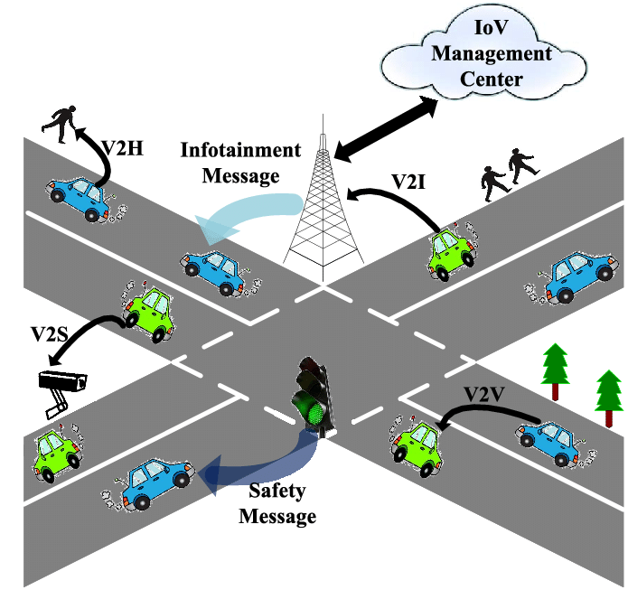
The growing research on connected car is one of the major areas being evolved under the umbrella of the Internet of Vehicles a sub-field of Internet of Things with the main focus of internet of vehicles being vehicles to everything communication, i.e., V2X also known as vehicle to infrastructure. The vehicle to everything communication is considered as one of the vital technologies explored by intelligent transport system i.e., ITS for traffic assistance in a smart city. V2X communication consists of Dedicated Short-Range Communications i.e., DSRC or cellular infrastructure, based on its requirement to their respective scenarios. Although, a combination of both the technologies can also deliver promising results with high throughput and low latency for more critical applications.
However, in recent years V2V has gained a lot of attraction because of its potential to make our journeys comfortable on the roads. The core requirement of IoV includes a reliable and fast communication with very low latency response to and from service providers. It needs to be more efficient to manage the huge number of requests simultaneously with no traffic congestion. Thus, a bayesian network is adopted in this research because of its ability to concisely represent probabilistic relationships and its previous successful application. However, other methods can also be utilized and intergrated to analyze data and perform predictions in this particular framework.
In the intelligent transportation system, the vehicle on the road initiates a new connection request towards the traffic controller in case of path failure and the traffic controller estimates a new point each time it receives a failure request using different protocols. This way of calculating position and a best path creates an extra overhead that results in more delayed traffic.
IoV communication paradigm possesses the ability to perform accurate positioning even in a blocked GPS signal scenario. In the typical setting of vehicular ad hoc networks, it has gained attraction from researcher’s world wide to address vehicle collision and traffic information dissemination issues. This ITS paradigm has a potential to bring enormous attention on the related area, such as traffic prediction, which has a potential to improve real-time performance. Machine learning has been heavily used in ITS mining data stream, constructing mathematical models and for exchange of information among vehicles. Due to link failure the packet drop ratio increases and thus calling for an efficient routing protocol to overcome these problems.
Software-Defined Networking i.e., SDN approach is preferred, SDN is a new revolution in which a control plane is separated from the data plane. Data plane in SDN accommodates dumb forwarding devices from different vendors while the control plane is known as the brain of the network where its intelligence lies, this approach is at its peak in most computer network fields. SDN enables the IoV to be managed in a logically centralized way through heterogeneous networks i.e, cellular network, RSUs, etc. recently, SDN has been considered mainly for its fixed network management, especially in access networks and data centres. SDN in VANETs has been a focus and proposed in recent years. However, its application still significantly misses to properly asses what extent SDN can assist and work with VANETs in IoV specifically with the wireless technology used to provide connection with SDN and the dynamic vehicle topology. As thus the proposed strategy of implementing SDN with IoV paves way towards centralized traffic management using different wireless technologies such as to control forwarding, short range communication and bandwidth.
A suitable protocol for data transmission in wireless networks can have good data quality with less or no delay and a number of routing protocols have been proposed for VANETs so far. However, each protocol has its own limitations according to working environment. Some protocols take the shortest path to forward the data packets, however, positioning is not always feasible due to vehicle topology changes.
Vehicular netowrks can hardly work directly with SDN based IoV regardless of the previously proposed protocols. This proposed strategy captures the neccesary requirements and components required for employment of SDN in vehicle environment, where reliable routing paths between vehicles can be calculated after obtaining network topology information from the vehicles on the roads. In case of controller failure, local agents inside the vehicles are can then switch to GPS routing mode to identify position and the best paths towards destination.

1.1 Research Significance
Irrespective of the exisiting protocols, proposing a routing protocol for IoV with reduced overhead has endured to be a challenge owing to the incompetence of the existing current architectures to manage flexibility and scalability. Therefore, this proposed architecture consolidates an evolving network standard SDN in IoV. Enables it to handle highly dynamic networks by dividing the data plane from the control plane. Intergrating a Hybrid road-aware routing strategy very high performance-enhanced routing protocol designed specifically for infrastructure-assisted VANETs where roads are divided into road segments, with road side units for multi-hop communication. The unique property of this proposed protocol aims to minimize distance travelled as well as time travelled which is used as a basis for comparison, The algorithm holds an advantage as it can reduce computational lad by updating traffic control information with previous traffic flow for optimization. The idea is to select the nearest position and selecet best paths for minimizing distance and prevent unnecessary traffic congestion.
The protocol also explores the cellular network to relay control messages to and from the controller with low latency hence proving effective and efficient.

1.2 Analysis of International Status of Research Topics
The main idea of software defined network is to partition the network control from forwarding devices. It provides centralized control and builds a simple network. The SDN networking pattern offers many advantages compared to the existing approaches. With a centralized control plane, it enables one to deploy standard as well as customize protocols to configure network devices. The proper customization of the protocols over the network assists researchers to deploy and visualize the updated protocols. Several researches have been done previously in the SDN field and its integration with IoV which is emerging out to be a promising future, the closed and proprietary way of managing network devices these days. Firmly believe due to the benefits SDN can bring, it is the right choice to bridge the gap between the road safety applications and IoV. An extended version of SDN into IoV is shown in Figure.
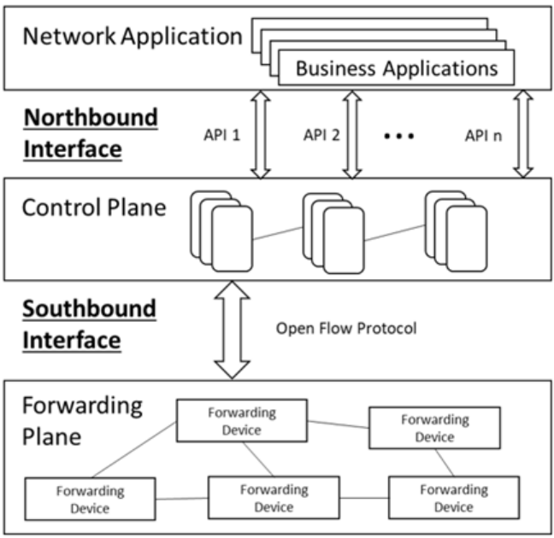
Routing protocols in IoV plays a key role in finding the best available paths in highly unstable vehicular environment (Cutolo et al. 2012; Manzoet al. 2012). Suitable protocol for data transmission in wireless networks can have a good data quality with less or no delay. Several routing protocols have been proposed for vehicular networks so far. However, each protocol has its own drawback and limitations according to their working environment. Some of the protocols takes the shortest path to forward the data packet but still selection of the best and safe path is not always feasible due to swift vehicle topology changes with short link lifetime. Furthermore, a number of protocols suggested follows greedy forward approach which may results in dead end.
Existing routing protocols of Vanets can be classified into different categories based on the type of information needed.
This example of topology-based protocol includes destination sequence distance vector (DSDV), dynamic source routing (DSR) and Ad hoc On-demand distance vector routing (AODV). Position based protocols includes greedy perimeter coordinator routing (GPCR) and intersection-based geographical routing protocol (IGRP). Map based protocols encompasses geographic source routing (GSR) and shortest-path-based and lastly road-based routing protocols consists of vehicle-assisted data Delivery. Regardless of the proposed protocols for vehicular networks, they still cannot directly apply on the SDN based IoV and require changes because of the ad-hoc nature.
Ku et al. (2014), proposed SDN based architecture for Vanets in order to provide the innovative services. The proposed architecture captures the requirement and components needed for the deployment of SDN in vehicular environment. Reliable routing paths between the vehicles are calculated by the controller after obtaining network topology information from the vehicles on the roads. However, in case of controller failure, local agents inside the vehicles are then switch to GPSR routing mode to find better paths towards the destination but a mobility problem is not considered which effects the SDN based protocol as whole with control overhead. Edge controller-based architecture is proposed in this paper to overcome this particular problem which helps the SDN controller in a way to pre-process the vehicle data. Controller receives a vehicle mobility data after certain intervals of time and its forwarded further towards the centralized controller if it has valuable information. This reception of real-time vehicle information also reduces the overhead from the SDN controller.
Zhu et al. (2015) proposed an architecture that extends the SDN into a routing mechanism for the Vanets to get intelligent message forwarding with minimized routing overhead. In order to calculate and maintain the shortest path with low latency between the vehicles, a new routing metric named as minimum optimistic time is designed. Truong et al. (2015) suggested a distinctive SDN-enabled architecture for the Fog computing with the support of both the servers such as safety and non-safety an orchestrator is added into the SDN controller for the creation of SDN-based Vanets Fog framework. Both authors Zhu et al. (2015) and Truong et al. (2015)
mainly focused their architectures on theoretical and architectural aspects, a detailed routing mechanism is still needed to support these results.
Jararweh et al. (2015) proposed an SDN based architecture for IoT to manage the devices more efficiently. Furthermore, proposed SDN based data forwarding, security, and storage mechanism: SDN data forwarding, SDN Sec, SDN Store. In order to solve the problem of low latency and manageability in IoT, Diro et al. (2018) proposed a framework by the integrating latest technologies: SDN and Fog computing. And being a part of user end data processing, fog computing plays a crucial role in reducing the latency of the critical IoT applications. A converged SDN framework is proposed for differential flow space allocation.
J. Moodabidri, et al (2017) proposed an SDN based Vehicle Ad-Hoc on-demand routing protocol. The protocol works at two different levels: a global level by distributed controllers i.e., RSUs, etc., and a local level that consists of vehicles on the road. Furthermore, roads are divided into non-overlapping road segments. And optimal paths are calculated between the road segments at the global level, paths inside the road segment are estimated by the local vehicles.
K. Ian, et al (2016) proposed SDN based framework to support vehicular networks. By using the network topology information, the SDN controller finds new paths between the source and the destination. However, in case of SDN failure, vehicle nodes switches to GPSR protocol for their normal operations of packet forwarding. SDN based framework is proposed by Z. Ming, et al (2015) is for efficient delivery of data packets in VANETs. The optimized path is calculated globally by the controller to relay the traffic through shortest and low routing overhead paths.
The contribution of paper is to have two centralized protocols: carry and forward approach and multi-hop forwarding approach, for lots of different scenarios.
J. Xiang, et al (2016) proposed one SDN-based geo-routing protocol for Vanets. The paper focuses on geographic routing which only takes the local information into account as to forward a packet which further promotes the problem of sparse connectivity local maximum. Two algorithms are explored in this approach: efficient path forwarding and packet forwarding. All vehicle transmits messages to the server and updates the vehicles state in Vanets. In order to update the vehicle state on the road, in the proposed algorithm every vehicle periodically transmits message. The source vehicle directly sends the packet if rules are installed for the destination into its flow table against the incoming packet. But in the opposite case, a request is transmitted towards the controller which calculates an optimal path between two nodes using a well-known Dijkstra's algorithm. The algorithm is endorsed to discover a path with high forwarding progress towards the destination and minimum hops.
However, in order to avoid sparse connectivity our proposed algorithm also considers the vehicle density parameter on the road. An optimal path between source and destination is then sent back to the source vehicle by the controller and after getting a reply, vehicle adds this path into the packet header, and the packet is then forwarded accordingly. The next hop is selected using the forwarding algorithm until so on until a packet reaches its destination. The intergrated Hybrid road-aware routing protocol was designed specifically for data transmission in VANETs. Roads are divided into road segments based on in-intersections.
HRAR introduces the concept of gateway vehicles to reduce control routing overhead. However, RREQ is not forwarded to every vehicle, but rather only sent towards the gateway vehicles who are further responsible to find the path in a multihop fashion. The protocol targets the VANETs only, which is considered as a distributed management system and does not consider the infrastructure-assisted communication. intergrated to the proposed protocol, results prove better packet delivery with reduce end-to-end delay and overhead.
Last but not least, all the above SDN based routing protocols proposed so far, hardly consider the major effect of vehicle position prediction on the performance of the network as well as the controller. After all this paper, focuses on solving traffic congestion by figuring vehicle position and best path possible. The model predicts a vehicle future location using an SDN-IoV Traffic routing procedure which handles traffic by incorporating probability theory using a Bayes Theorem. Controllers are implemented to estimate real-time traffic from the vehicles for location estimation locally and a request is forwarded towards the SDN controller if the destination is out of range.

2. Research Objective and Contents

2.1 Research Objective
The purpose of this paper is to illustrate effectiveness and efficiency of the predictions of vehicle possible position and identifying the best path inside and outside its vicinity by improving data forwarding schemes.
Specifically, this study aims to:
- Determine stable path by predicting the vehicle position in SDN based IoV.
- Improve on IoV communication short comings with service providers such as path failure, low latency response.
- Determine vehicle mobility scenarios to improve prediction accuracy
- To enhance path estimation and traffic control with improved and efficient routing.

2.2 Research Contents
We introduce a traffic routing procedure SDN-IOV which is able to handle traffic by incorporating probability theory. Particularly the model uses Bayes Theorem and probabilities of vehicle congestion and traffic flow to estimate location and best path for vehicles to take. The protocol aims to minimize distance travelled as well as time travelled which is used as a basis for comparison, The algorithm holds an advantage as it can reduce computational lad by updating traffic control information with previous traffic flow for optimization. The idea is to select the best paths for minimising distance and prevent unnecessary congestion.

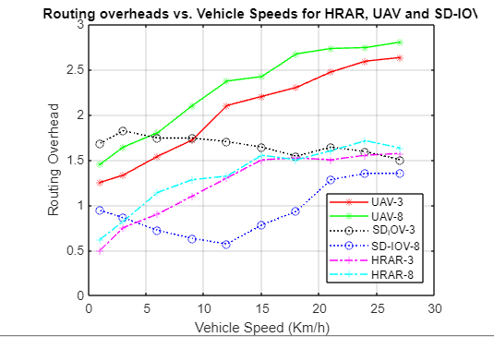

The routing overhead for all three protocols is computed. It can be observed that routing overhead increases significantly with the average speed of the vehicle. Figure shows the routing overhead for the HRAR, SDN-IoV increases traffic in denser road segments due to the high redundancy. When there are more RSUs for the SDN-IoV algorithm there is initially less routing overhead and as vehicle move from less cogested traffic areas (increase in speed) but the overhead increases at around 10KM/ plus. That being the case bayesian probability SDN-IoV maintains minimum overhead at most speeds especially with more RSUs.

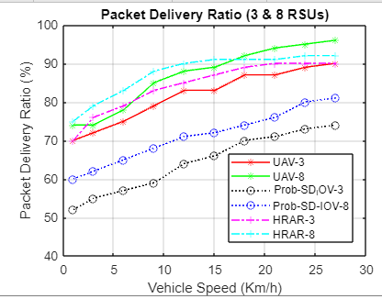

The packet delivery ratios were assessed in relation to the speed of vehicles as given by different discreet node speeds.

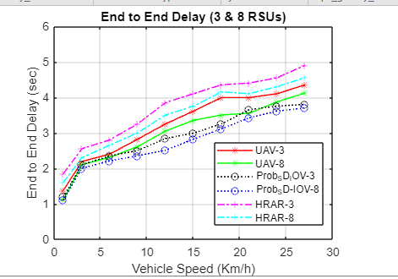

End to end delay is a direct result of the number of hops and traffic on the network, The controller ensures that each road segment sends out data to RSUs in a reactive manner (only when necessary). For this reason, the proposed method is able to send out packets of data faster and can be seen to outperform other methods namely Unmanned aerial vehicles and HRAR.

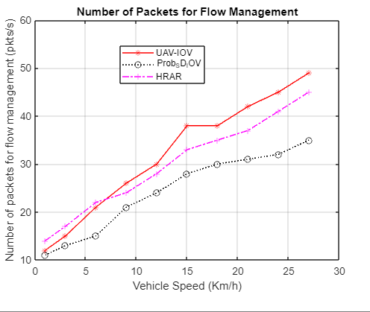
Our proposed methods shows that there are less control messages being transmitted between the switch and the controller compared to HRAR and the UAV method which is based on the ID of the vehicle. The SD-IOV with probability measure is more effective as it takes the road segment ID rather than car ID making the flow of control messages easier and mo efficient. Road segments are more constant as compared to vehicles which are constantly moving and require messages on link failures to be transmitted every time a car moves out of range.

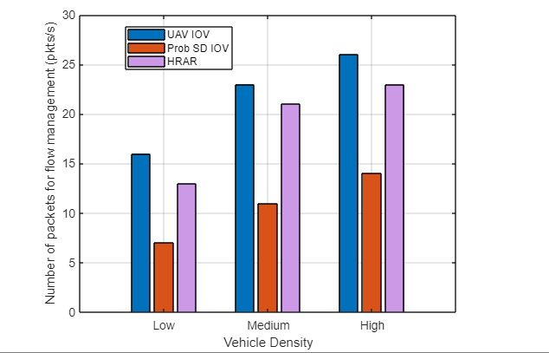

For all traffic densities it is evident that the proposed algorithm outperforms the other algorithmswith the lowest number of packet messages being sent between the controller and switch. The ranges for traffic densities were given as 1-15 vehicles, medium traffic was 16-35 vehicles and high traffic had 36 and more.

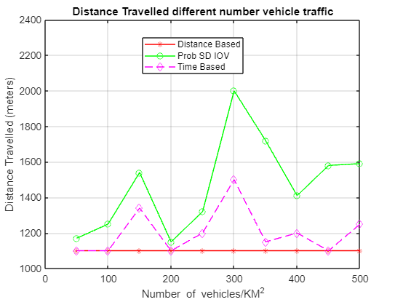
Total distance traveled was measured using a standard distance based and a standard time-based path selection algorithm. In all traffic scenarios it is observed that the probability-based SDN-IoV results in the longest distance travelled with a significant spike between 200-300 vehicles per KM-square. The algorithm prioritized traffic routing such that there is reduced traffic congestion and cars are redirected to available road segments optimizing on both time and distance.
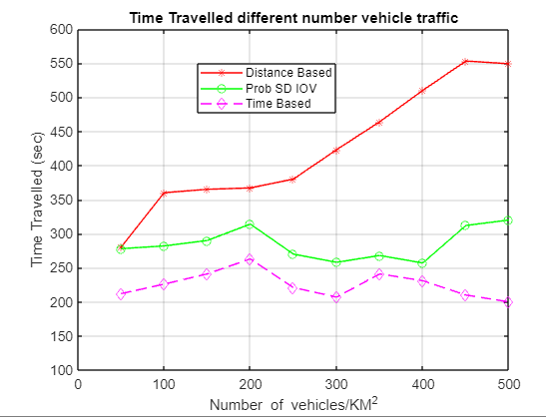
Time spent travelling is marginally low and balanced for all various traffic congestion levels. The algorithm makes a tradeoff between distance and time by estimating the likelihood that there will be traffic and creating optimal route plans.

2.3 Key Issues and Innovation
Motion of vehicles in internet of vehicles is limited to roads with the support of fixed structure. Hence, the inspiration for this proposed research. In this approach, a traffic routing procedure SDN-IoV is proposed. The protocol is able to handle traffic by incorporating probability theory to anticipate the significance for position and route length among the source vehicle and a destination. The model uses a bayes theorem and probabilities of vehicle congestion and traffic flow to estimate the nearest position and best path for vehicles to take. proposed protocol is different from the previous protocols in a number of ways:
- This protocol aims to minimize distance travelled and time travelled which are both used as a basis for comparison.
- Reduces computational lad by updating traffic control information with previous traffic flow for optimization.
- Prevents unnecessary congestion.

3. Research Scheme and Technology Roadmap

3.1 Research Scheme
This paper aims to solve effectiveness of predictions of vehicles nearest position and identifying the best path in its vicinity by improving data forwading using Bayes Theorem. The algorithm has better advantage as it can reduce computational lad by updating traffic control information with previous traffic flow for optimization. The main idea is to select the best paths by minimizing distance and preventing unnecessary congestion.

3.2 Technology Roadmap
SDN-IoV Enabled approach is a performance-enhanced routing protocol designed specifically for infrastructure-assisted vehicular networks. With this, a program is required to explore the underlying topology information in order to describe the rules to forward the data, and every vehicle acts as forwarding device. The proposed mechanism splits the control traffic from the data traffic by the separation of communication channels, RSUs can be utilized for data forwarding and cellular network can be used for the transmission of control traffic. In SDN-IoV, vehicles are recognized as OVS with data flow rules installed in flow tables. The proposed architecture takes an intergrated traffic routing procedure SDN-IOV which handles traffic by incorporating probability theory. The model uses Bayes Theorem to evaluate probabilities of vehicle congestion and traffic flow to estimate the nearest position and best path for vehicles to take. The main aim is to minimize distance and time travelled which is used as a basis for comparison, The proposed algorithm holds a lot of advantage as it can reduce computational load by updating traffic control information with previous traffic flow for optimization.

4. Basic of Research

4.1 Research Conditions
The proposed research uses a qualitative method design based on previous publications and articles that refer to the Internet of Vehicles and routing protocols. Particularly the architecture studys and introduces an SDN-IoV Traffic routing procedure which uses Bayes Theorem and probabilities of vehicle congestion and traffic flow to estimate the nearest position and best path for vehicles. Matlab source is considered to conduct and evaluate framework. Lastly this research is aimed purposely to prove the importance of vehicle position prediction for vehicular networks.
This research was carried out at the University of Science and Technology Beijing, with Supervision of Wanglina Laoshi.

4.2 Problems Encountered
Being a largely growing industry even in the first world the major problem while conducting this was mostly knowledge based, it’s been fresh topic to my ears and had to educate myself about it. Another major factor was the limited information available on the existing topic i.e., less publications and articles on SDN and IoV. Lastly it was hard to find and settle down on a topic especially since since it’s a fresh area of study

5. Research Plans, Final Outcome Form, Technology Index and Its Application Directions

5.1 Work plans
Project Task | Estimated time
Research from books, journals and internet | 3 months
Data collection | 1 month
Analyzing Results: Comparing and Contrasting assimilation results | 4 months
Conclusion and Recommendation (thesis writing) | 2 months

5.2 Final Outcome Form
The proposed research will qualify my course study completion and eligible to graduate for my Masters in Information and Telecommunication Engineering.

5.3 Technology Index
Some of the key technologies in this proposed research include Intelligent Transportation System i.e., ITS, Dedicated Short Range Communications i.e., DSRC, Traffic controller i.e., TC, Vehicle to Anything i.e., V2X, Vehicle to Vehicle i.e., V2V, Position prediction, Software Defined Network i.e., SDN, controllers i, Internet of Vehicles i.e., IoV, Geographical Information System i.e., GIS, Global Positioning System i.e., GPS and Mcs

5.4 Application Directions
This proposed research will serve as a step further for the Vehicle environment, Human interaction and study reference for other scholars hoping to follow the same direction. It will also serve as another stepping stone towards traffic management, road safety and accident control thus reduce accidents and other vehicle road foul plays.

Reference
- G. Mario, et al., “Internet of vehicles: From intelligent grid to autonomous cars and vehicular clouds,” in Proc. IEEE World Forum on Internet of Things (WF-IoT), 2014
- Abbas MT, Song WC “A path analysis of two-level hierarchical road, aware routing in VANETs,” in Ninth International Conference on Ubiquitous and Future Networks (ICUFN), IEEE, pp 940–945. 2017
- S. Hanbyul, et al., “LTE evolution for vehicle-to-everything services,” IEEE Communications Magazine, vol. 54, no. 6, pp. 22-28, 2016
- T. Nguyen, G. M. Lee, and Y. Ghamri-Doudane, “Software defined networking-based vehicular adhoc network with fog computing,” in Proc. IFIP/IEEE International Symposium on Integrated Network Management, 2015.
- Z. Ming, et al., “SDN-based routing for efficient message propagation in VANET,” in Proc. International Conference on Wireless Algorithms, Systems, and Applications, Springer, Cham, 2015
- Baihong. D, et al., “Software defined networking based on-demand routing protocol in vehicle ad hoc networks,” in Proc. 12th International Conference on Mobile Ad-Hoc and Sensor Networks, 2016
- A. M. Tahir and W. C. Song, “Infrastructure-assisted hybrid road-aware routing and qos provisioning in vanets,” in Proc. 19th Asia-Pacific Network Operations and Management Symposium, 2017
- F. Li and Y. Wang, "Routing in vehicular ad hoc networks: A survey", IEEE Veh. Technol. Mag., vol. 2, no. 2, pp. 12-22, Jun. 2007.
- Abbasi IA, Nazir B, Abbasi A, Bilal SM, Madani SA” A traffic flow-oriented routing protocol for vanets,” EURASIP J Wireless Communication Network (1):121, 2014
- J. Xiang, et al., “SDGR: An SDN-based geographic routing protocol for VANET,” in Proc. IEEE International Conference on Internet of Things (iThings) and IEEE Green Computing and Communications (GreenCom) and IEEE Cyber, Physical and Social Computing (CPSCom) and IEEE Smart Data, 2016.
- K. Ian, et al., “Towards software-defined VANET: Architecture and services,” Med-Hoc-Net. 2014
- V. D. K. Nooji, S. B. Srikantaiah, and J. Moodabidri, “SCGRP: SDN-enabled connectivity-aware geographical routing protocol of VANETs for urban environment,” IET Networks, vol. 6, no. 5, pp. 102, 2017
- M. Tahir, A. Muhammad, and W. C. Song, “SD-IoV: SDN enabled routing for internet of vehicles in road-aware approach,” Journal of Ambient Intelligence and Humanized Computing, pp. 1-16, 2019
- A. Zubair, et al., “Low latency V2X applications and network requirements: Performance evaluation,” in Proc. IEEE Intelligent Vehicles Symposium, 2018.
- A. M. Tahir, A. Muhammad, and W. C. Song, “Road-Aware estimation model for path duration in internet of Vehicles (IoV),” Wireless Personal Communications, pp. 1-24, 2019.
- B. T. Nguyen, G. M. Lee, and Y. Ghamri-Doudane, “Software defined networking-based vehicular adhoc network with fog computing,” in Proc. IFIP/IEEE International Symposium on Integrated Network Management, 2015
- Devangavi AD, Gupta R “Routing protocols in VANET–a survey,” In: 2017 International Conference on Smart Technologies for Smart Nation (SmartTechCon), IEEE, pp 163–167, 2017
- O. Kaiwartya, S. Kumar and R. Kasana, "Traffic light-based Time Stable Geocast (T-TSG) routing for urban VANETs", Proc. 6th IC3, pp. 113
- Ding Q, Sun B, Zhang X “A traffic-light-aware routing protocol based on street connectivity for urban vehicular ad hoc networks,” IEEE Commun Lett 20(8):1635–1638, 2016
- Lin D, Kang J, Squicciarini A, Wu Y, Gurung S, Tonguz O “Mozo: a moving zone-based routing protocol,” using pure v2v communication in vanets. IEEE Trans Mob Comput 16(5):1357–1370, 2017

